# 3 Design

## 3.1 Design Context

### 3.1.1 Broader Context

*Describe the broader context in which your design problem is situated. What communities are you designing for? What communities are affected by your design? What societal needs does your project address?*

*List relevant considerations related to your project in each of the following areas:*

| **Area** | **Description** | **Examples** |
| --- | --- | --- |
| Public health, safety, and welfare | How does your project affect the general well-being of various stakeholder groups? These groups may be direct users or may be indirectly affected (e.g., solution is implemented in their communities) | This project will give stakeholders an understanding of the existing and historical health effects of electricity generation. This will allow for more educated decision making in regards to how to improve the electricity grid to reduce the harmful effects of pollution. |
| Global, cultural, and social | How well does your project reflect the values, practices, and aims of the cultural groups it affects? Groups may include but are not limited to specific communities, nations, professions, workplaces, and ethnic cultures. | This project advances the social responsibility and transparency of MISO and their planning engineers. By using open data and displaying it in an accessible format for the general public, electricity consumers are better educated on the effects of their behavior. This project promotes the values of transparency and environmental consciousness. |
| Environmental | What environmental impact might your project have? This can include indirect effects, such as deforestation or unsustainable practices related to materials manufacture or procurement. | Our project will allow MISO customers to better understand the environmental impacts of their electricity usage. This allows for more educated decision making on environmental grounds. |
| Economic | What economic impact might your project have? This can include the financial viability of your product within your team or company, cost to consumers, or broader economic effects on communities, markets, nations, and other groups. | Product has minimal costs in implementation, but awareness of the data presented could distort electricity demand depending on the time of day, etc. This potential distortion of the market while seeking lower emissions could adversely impact consumers in states with more liberalized electricity pricing models via demand fluctuations.  Additionally, the clear data presented in this project could drive decision making in future network planning, in a manner that could financially benefit the producers of clean energy. |

### 3.1.2 User Needs

*List each of your user groups. For each user group, list a needs statement in the form of:*

*User group needs (a way t0) do something (i.e., a task to accomplish, a practice to implement, a way to be) because some insight or detail about the user group.*

MISO customers (Utilities) need a way to see the emissions profile of the entire MISO network to better understand where and how to introduce more clean energy into their networks.

Electricity ratepayers and concerned citizens need to understand the emissions profile of their electricity usage in order to find ways to alter their behavior to reduce their environmental impacts.

MISO wants to collate a large amount of data about generation emissions as customers, regulators, and similar groups will demand more detailed information about generation emissions in the future.

### 3.1.3 Prior Work/Solutions

*Include relevant background/literature review for the project sources and include them in your references. All figures must be captioned and referenced in your text.*

California ISO has produced a dashboard[1] showing the historical, real time, and source of CO2 emissions in the electricity generation occurring in their footprint. This dashboard contains a variety of time scales, sources, and contexts that help explain the trends in CO2 emissions in a clear manner. Another advantage of the dashboard is the hyperlinking of official government sources that give more context to the data and the statutory regime that necessitates and produces the data. Additionally, the dashboard is consistent with the rest of the ISO’s website in terms of visual standards and visual appeal. One shortcoming of the database is the lack of information on the exact sources of the CO2 emissions beyond the fuel used in generation. Ideally, a customer would have some information about the region where the electricity is being produced, and some more insight into pollutants besides CO2.

Other ISO’s such as New York ISO[2], ISO-New England[3], and Southwest Power Pool[4] have produced dashboards that visualize the mix of fuels used in generation of electricity in their regions. These dashboards succeed in communicating the fuel mix, but lack detailed context on the emissions impacts of this mix. The dashboards are all clear and simple to understand, and many contain the option to interact with the data or download the source data. This interactivity is very important and allows for stakeholders to engage with our project in an intimate fashion and should be integrated as a feature in our design.

“Todays Emissions,” *California iso - emissions, today's outlook*. [Online]. Available: https://www.caiso.com/TodaysOutlook/Pages/emissions.html. [Accessed: 14-Oct-2021].

“Real Time Dashboard,” *NYISO*. [Online]. Available: https://www.nyiso.com/real-time-dashboard. [Accessed: 14-Oct-2021].

“Real-time maps and charts,” *ISO New England - Real-Time Maps and Charts*. [Online]. Available: https://www.iso-ne.com/isoexpress/web/charts. [Accessed: 14-Oct-2021].

Southwest Power Pool, “Generation Mix,” *Generation mix*. [Online]. Available: https://marketplace.spp.org/pages/generation-mix. [Accessed: 14-Oct-2021].

### 3.1.4 Technical Complexity

### *Provide evidence that your project is of sufficient technical complexity. Use the following metric or argue for one of your own. Justify your statements (e.g., list the components/subsystems and describe the applicable scientific, mathematical, or engineering principles)*

1. *The design consists of multiple components/subsystems that each utilize distinct scientific, mathematical, or engineering principles –AND–*
2. *The problem scope contains multiple challenging requirements that match or exceed current solutions or industry standards.*

Our design will integrate distinct systems to import and display information about the MISO generation network, the historical and real time emissions of the MISO network, and the regional breakdowns of this data. This includes databasing the included sources for future use and recording for stakeholders and displaying information to the user using integrated code to display this data. This will use various data science principles to extract data from the source and manipulate it for easy display.

## Design Exploration

### 3.2.1 Design Decisions

*List key design decisions (at least three) that you have made or will need to make in relation to your proposed solution. These can include, but are not limited to, materials, subsystems, physical components, sensors/chips/devices, physical layout, features, etc.*

Our design will need to have at a minimum, a Graphical User Interface (GUI), information access and availability for the general public, and software for real time updating of the GUI. The GUI will encompass the emissions dashboard and the intractability by a public user. The software will have to poll data from data sources to update the emissions chart daily at a minimum, with a stretch goal of possibly by five minute intervals. The accessibility for the general public will mean that the data sourced will have to be obtained from public sources so the regular user doesn’t need additional policies to allow them to access information.

### 3.2.2 Ideation

*For one design decision, describe how you ideated or identified potential options (e.g., lotus blossom technique). List at least five options that you considered.*

For our GUI design decisions, we had to think about how we could make our GUI best display the data we had in a way to make it as user friendly as possible. For our lotus blossom of GUI design, we had the word GUI surrounded by Interactibility, Colored Overlays, Legends, Download Ability, and Live Updating. We were able to ideate these decisions based on thinking upon what our stakeholders desired most from the input they had given to us as well as some of the features we observed on similar projects that had been already developed.

### 3.2.3 Decision-Making and Trade-Off

*Demonstrate the process you used to identify the pros and cons or trade-offs between each of your ideated options. You may wish you include a weighted decision matrix or other relevant tool. Describe the option you chose and why you chose it.*

To understand the pros and cons of our design decisions, we did basic pro/cons of each of our decisions. For example, when we looked at the decision to make our GUI Interactable, we came up with the following pro/con arguments. For the pro’s of making the GUI intractable, we had increased usability to focus on singular trends, better aesthetics, and screen space reduction. For the negatives of this decision we found increased development time, more edge case coding, able to handle varied data sets, and limited by existing tableau options. We chose this method of decision making because it’s the most simple and useful way to analyze costs and benefits.

## Proposed Design

*Discuss what you have done so far – what have you tried/implemented/tested?*

The proposed design consists of an emissions dashboard similar to what California ISO has on their website, with how they have their CO2 resources charted in trends and charts, with included historical data. Research is being conducted still on how to implement this data into a website interface user using High Chart, a JavaScript library. Data will be polled from external sources such as Energy Information Administration and MISO’s websites.

### 3.3.1 Design Visual and Description

*Include a visual depiction of your current design. Different visual types may be relevant to different types of projects. You may include: a block diagram of individual components or subsystems and their interconnections, a circuit diagram, a sketch of physical components and their operation, etc.*

*Describe your current design, referencing the visual. This design description should be in sufficient detail that another team of engineers can look through it and implement it.*

The design on the dashboard will cover the emissions data from the North, Central, and South regions of MISO’s area of operations. The user will be able to independently access each region, meaning emissions data from other MISO regions will be filtered out in order for easy access to the needed information and trends. There will be various charts, graphs, and tables that will display which regions are hitting their emissions targets, trends of emission data, and show a historical outlook of how a region's emissions are affected by different variables. The visual of the screen will be shown below:

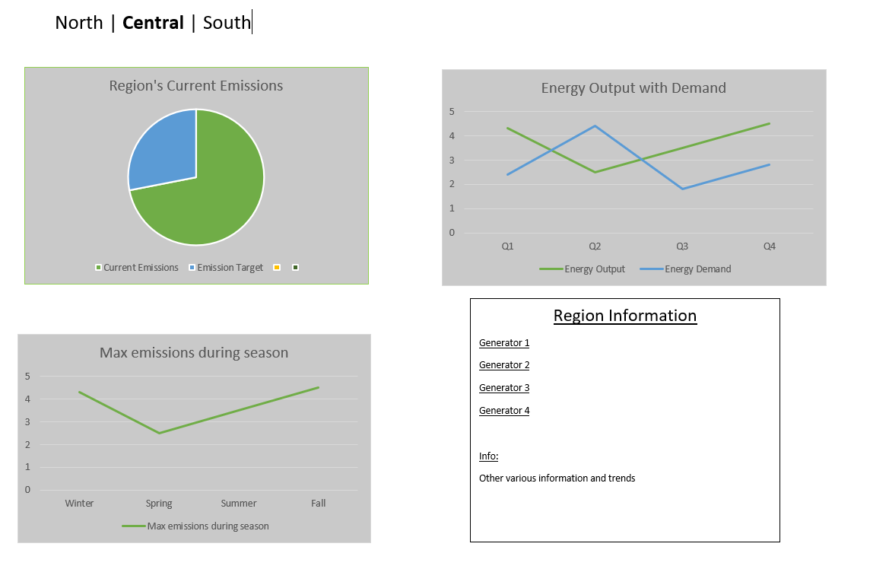

### 3.3.2 Functionality

*Describe how your design is intended to operate in its user and/or real-world context. This description can be supplemented by a visual, such as a timeline, storyboard, or sketch.*

*How well does the current design satisfy functional and non-functional requirements?*

Users will be able to publicly access this dashboard on MISO’s website. We will implement interactable maps and data for easy UI traversal for the user and for quick data gathering. The goal of this dashboard is to allow MISO to see how various trends impact emissions of each MISO region, and customers of MISO can see how their activities impact their emissions data so they can more easily regulate their activities in order to hit set emission targets.

Currently, all functional and non-functional requirements are satisfied due to the many conversations about the design and implementation of features with MISO. Javascript along with its Highchart library will be used to cover these requirements.

### 3.3.3 Areas of Concern and Development

### *Based on your current design, what are your primary concerns for delivering a product/system that addresses requirements and meets user and client needs?*

Primary concerns:

1. Data sources moving or links breaking.
2. Dashboard layout and/or functionality do not meet customer’s (MISO) vision of product.
3. Estimated emission information is not accurate or detailed enough for customer requirements.
4. User experience interacting with the dashboard is less than desired.
5. Project is successful but is not able to be maintained or updated by the customer.

*What are your immediate plans for developing the solution to address those concerns? What questions do you have for clients, TAs, and faculty advisers?*

1. Data sources moving or links breaking.
   1. Properly document code and design for the possibility of data sources moving. For example, create a SOP for updating any broken data sources, have the code look and notify that “DATASOURCE_X” is missing, etc.
2. Dashboard layout and/or functionality does not meet customer’s (MISO) vision of product.
   1. Ensure that the customer specifications (listed in MISO provided document “Project Requirements” (PR) Section 2) are implemented early in the development.
   2. Early prototyping of the dashboard to share with the customer.
   3. Maintain open communication with the customer throughout the development process.
3. Estimated emission information is not accurate or detailed enough for customer requirements.
   1. Develop a clear plan for data collection, manipulation, and calculations required and share this plan with the faculty adviser and MISO before major programming tasks begin.
   2. Record clear documentation of all data sources accessed, assumptions made, data calculations or manipulations performed, etc. to ease any modifications requested by the customer during the development process.
4. User experience interacting with the dashboard is less than desired.
   1. Create a test server to host the dashboard during development.
   2. Perform various tests and performance evaluations as the dashboard evolves.
   3. With each successive iteration of the dashboard, obtain input from the customer or ask fellow students to test out UI to locate potential problems or improvements.
5. Project is successful but is not able to be maintained or updated by the customer.
   1. Create proper documentation on how to use the dashboard, how to perform critical maintenance such as changing data sources, adding data views, etc.
   2. Properly format and document all code so that it is easy to understand and edit.